**Requerimientos**

# Index

**Index 2**

**Resume 2**

**Objective 2**

**Functional requirements 3**

Prioritization of use cases 3

**non-functional requirements 3**

**Information requirements 5**

MER Diagram 5

Data Dictionary 6

**Business rules 7**

**Interface requirements 7**

Application sketch 7

# Resume

This document establishes the requirements that the **Funkos** project will have, showing the limitations and attributes that the proposed solution system will have.

# Objective

Define 100% of the functionalities and specifications of the system to be developed from Tuesday 27 to Friday 30 July 2023.

# Functional requirements

[Functional requirements.xlsx](https://docs.google.com/spreadsheets/d/1P2KjLopRvfIiXqyqR7WPyTempxjLLNCl/edit#gid=633445318)

## Prioritization of use cases

[Functional requirements.xlsx](https://docs.google.com/spreadsheets/d/1P2KjLopRvfIiXqyqR7WPyTempxjLLNCl/edit#gid=633445318)

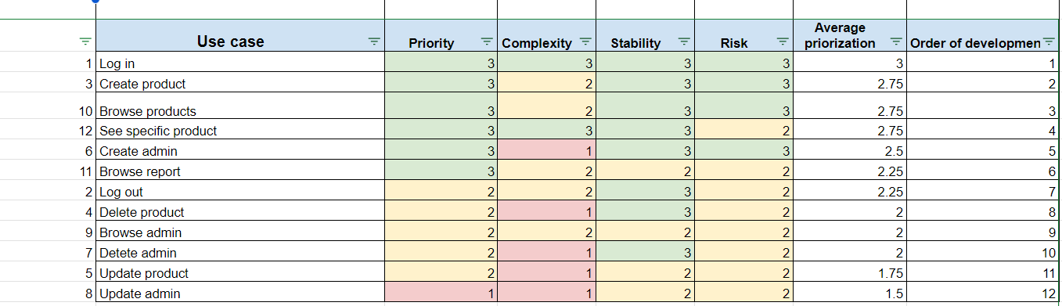

# 

# non-functional requirements

* Usability:
  + End users will be able to use the system after a 15-minute training session.
* Security:
  + The system will handle user logins using tokens through JSON Web Tokens.
  + The system will have role-based access control.
  + The system will restrict access to certain user information based on role level.
  + The administrator will need to log in to access administrative functions.
  + Accessing and modifying the database will require specific authorization.
* Portability:
  + The system will be compatible with the latest versions of Chrome and Edge.
  + The system will be responsive across different screen resolutions.
* Maintainability:
  + The system will have adequate documentation following the UML OMG 2.0 standard to facilitate its performance by an external development team.
  + Existirán logs con información necesaria para detectar rápidamente defectos en caso de que sucedan.
  + Se utilizarán pruebas automatizadas en los requerimientos de prioridad alta para validar el software.
* Availability:
  + The system can be used as long as the server is active and there is an internet connection.
  + The server should be available 99.99% of the time.
* Performance::
  + The system is capable of supporting up to 50 simultaneous users without exceeding 10% of the average response time.
  + The system should be able to load information within a range of 2 to 15 seconds, depending on the type of information.
  + The system should be able to upload information within a range of 2 to 15 seconds, depending on the type of information.

**Architecture**

Front end.

* **React** 
  + HTML 5
  + JavaScript

Back end.

* **Node js.** 
  + JavaScript
  + Express

Style:

* **Bootstrap**

Data base.

* **Atlas MongoDB**
  + No relational

Security:

* **JSON Web Token**

Deply:

* **Digital Ocean**

Operating system

* **Ubuntu**
* Version 20.04 LTS

**Initial Software architecture diagram:**

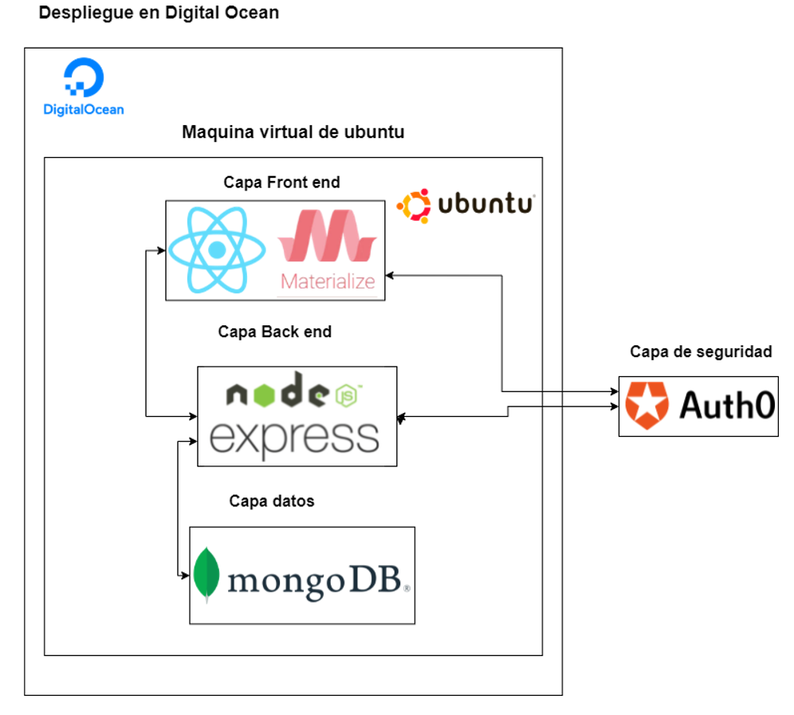

**Final Software architecture diagram:**

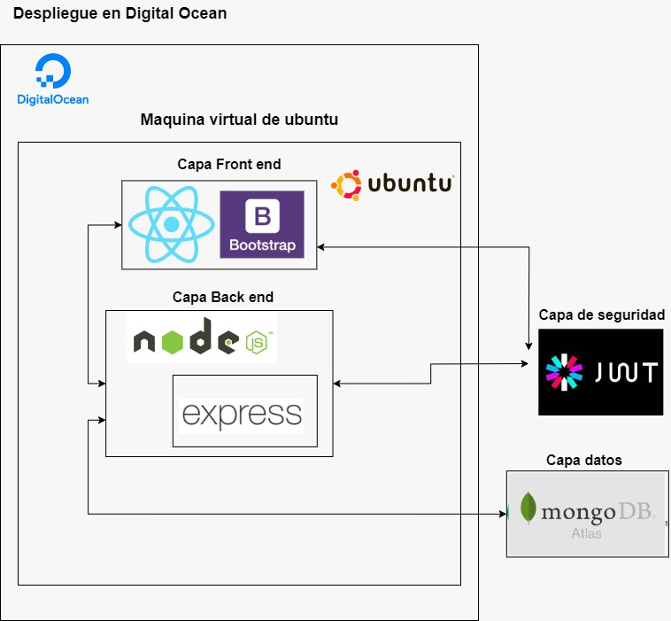

# Information requirements

## MER Diagram

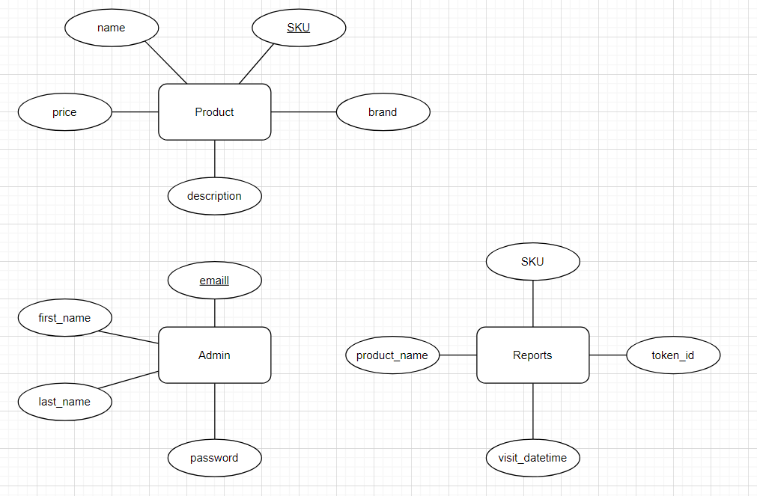

## Data Dictionary

**Entity: Product**

| **Attribute name** | **Description** | **data type** | **Example** | **Validation** |
| --- | --- | --- | --- | --- |
| **SKU** | ID of the product | int(8) | 00000001 | Unique id |
| **name** | Name of the product | string | Funko Naruto | NOT NULL |
| **price** | price of the product | Float | 240.99 | NOT NULL |
| **description** | Description of the product | string | Funko del personaje Naruto | NOT NULL |
| **brand** | Brand of the product | string | Mattel | NOT NULL |

**Entity: Admin**

| **Attribute name** | **Description** | **data type** | **Example** | **Validation** |
| --- | --- | --- | --- | --- |
| **email** | email of the admin | alphanumeric(32) | davidguzley@hotmail.com | NOT NULL |
| **password** | password of the admin | alphanumeric(32) | Password123 | NOT NULL |
| **first_name** | name of the admin | string | David | NOT NULL |
| **last_name** | last name of the admin | string | Guzman | NOT NULL |

# 

**Entity: Reports**

| **Attribute name** | **Description** | **data type** | **Example** | **Validation** |
| --- | --- | --- | --- | --- |
| **SKU** | ID of the product | int(8) | 00000001 | NOT NULL |
| **token_id** | unique id of the anonymous user | alphanumeric(64) | LASKDNJKASKDHUI213 | NOT NULL |
| **visit_datetime** | datetime when the user click a product | datetime | Oct 18 2023 12:54:45 | NOT NULL |
| **product_name** | name of the product | string | Funko Naruto | NOT NULL |

# Business rules

* Only admins can update, delete and create new admins and products

# Interface requirements

## 

## Application sketch

[Figma Design](https://www.figma.com/file/6gFAnT6g7p7Evnwakwyan2/Catalog-Design?type=design&node-id=0%3A1&mode=design&t=YOcWTDY7VXygE10M-1)